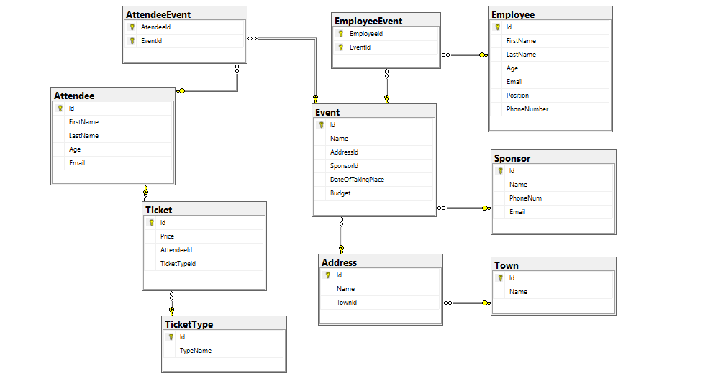Event Management System

Town

|  |  |  |
| --- | --- | --- |
| Column name | Data type | Constraints |
| id | int | PK, Unique table identification, Identity |
| Name | String up to (200) symbols, Unicode | Null is not allowed |

Address

|  |  |  |
| --- | --- | --- |
| Column name | Data type | Constraints |
| id | int | PK, Unique table identification, Identity |
| Name | String up to (200) symbols, Unicode | Null is not allowed |
| TownId | int | Relationship with table Towns, Null is not allowed |

Attendee

|  |  |  |
| --- | --- | --- |
| Column name | Data type | Constraints |
| id | int | PK, Unique table identification, Identity |
| FirstName | String up to 50 symbols,unicode | Null is not allowed |
| LastName | String up to 50 symbols,unicode | Null is not allowed |
| Age | int |  |
| Email | String up to 100 symbols | Null is not allowed |

Sponsor

|  |  |  |
| --- | --- | --- |
| Column name | Data type | Constraints |
| Id | int | PK, Unique table identification, Identity |
| Name | String up to 100 symbols | Null is not allowed |
| Phone Number | String up to 10 symbols | Null is not allowed |
| Email | String up to 100 symbols | Null is not allowed |

Employee

|  |  |  |
| --- | --- | --- |
| Column name | Data type | Constraints |
| Id | int | PK, Unique table identification, Identity |
| FirstName | String up to 50 symbols,unicode | Null is not allowed |
| LastName | String up to 50 symbols,unicode | Null is not allowed |
| Age | int | Null is not allowed |
| Email | String up to 100 symbols | Null is not allowed |
| Position | String up to 100 symbols | Null is not allowed |
| Phone Number | String up to 10 symbols | Null is not allowed |

TicketType

|  |  |  |
| --- | --- | --- |
| Column name | Data type | Constraints |
| Id | int | PK, Unique table identification, Identity |
| TicketName | String up to 100 symbols | Null is not allowed |
|  | | |

Ticket

|  |  |  |
| --- | --- | --- |
| Column name | Data type | Constraints |
| Id | int | PK, Unique table identification, Identity |
| Price | Decimal number with two-digit precision | Null is not allowed |
| AttendeeId | int | Relationship with table Attendee, Null is not allowed |
| TicketTypeId | int | Relationship with table Ticket, Null is not allowed |

Event

|  |  |  |
| --- | --- | --- |
| Column name | Data type | Constraints |
| Id | int | PK, Unique table identification, Identity |
| Name | String up to (100) symbols, Unicode | Null is not allowed |
| AddressId | int | Relationship with table Address, Null is not allowed |
| SponsorId | int | Relationship with table Sponsor, Null is not allowed |
| DateOfTakingPlace | Date | Null is not allowed |
| Budget | Decimal(12,2) | Null is not allowed |

AttendeeEvent

|  |  |  |
| --- | --- | --- |
| Column name | Data type | Constraints |
| AtendeeId | int | PK, Unique table identification, Relationship with table **Attendee**, **Null** is **not** allowed |
| EventId | int | PK, Unique table identification, Relationship with table **Event**, **Null** is **not** allowed |

EmployeeEvent

|  |  |  |
| --- | --- | --- |
| Column name | Data type | Constraints |
| EmployeeId | int | PK, Unique table identification, Relationship with table **Attendee**, **Null** is **not** allowed |
| EventId | int | PK, Unique table identification, Relationship with table **Event**, **Null** is **not** allowed |